Guidelines for the Interface

For this assignment, the standard User Interface Design guidelines and procedures were followed with utmost attention. These guidelines and procedures are followed by large and successful companies such as Amazon, Apple and Google. Some of these guidelines and procedures which we followed in our system can be found below.

1. Minimizing the problems related to data input as much as possible

Within this project, input from the user is mainly taken by the use of large selection buttons as shown in Figure 2. As a result, the input is limited to the certain options presented to the user only. Therefore there is less room for input errors from the user’s side.

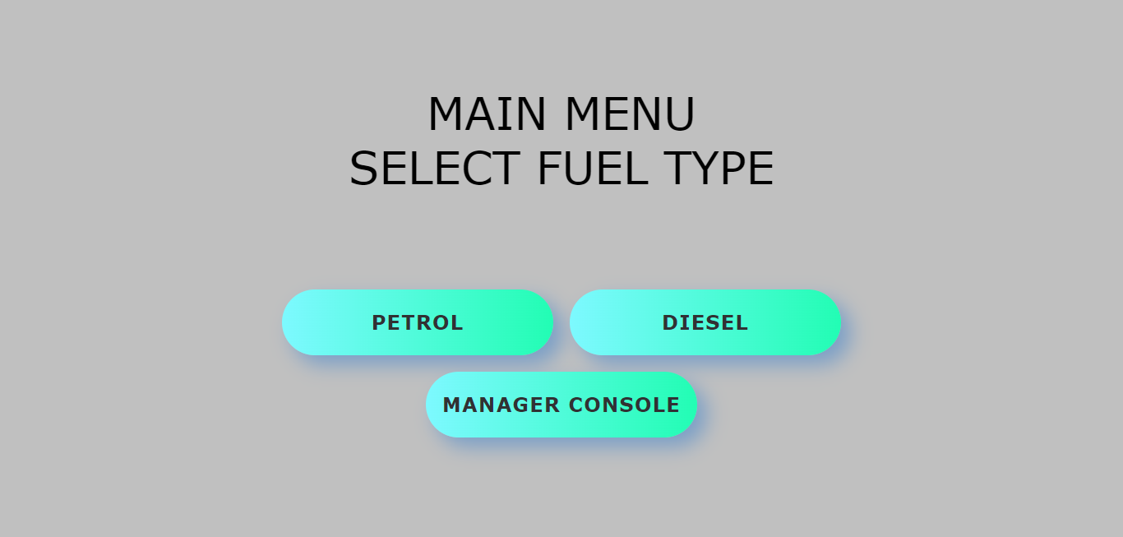

Figure 2

However, there are three scenarios in which the user is requested to make an input with the use of a keypad. These are: inputting the amount of money worth of fuel to fill the vehicle, inputting the passcode to enter the Manager’s Console and entering a new fuel price inside the Manager’s Console. With this input method, various input errors can take place, but we made sure that errors were prevented as much as possible.

Inputting the passcode to enter the manager’s console

In this scenario, the manager has to input the 4-digit passcode. The correct passcode for our system is 1234. Input error avoidance was taken care of by limiting the manager to 4-digit passcodes, instead of allowing the manager to have passcodes with varying lengths and different input characters from numbers. Adding to this, security was also safeguarded since it is difficult to crack the passcode, knowing the many combinations available by a 4-digit passcode. Moreover, an unauthorized user is also denied access, since an incorrect passcode or left empty passcode will leave the user outside of the Manager’s Console.

Changing price of a fuel by the manager

Like when inputting the passcode to enter the Manager’s Console, the keypad with limited digits (0 - 9) is also displayed when the manager is going change the price of a particular type of fuel. As a result, we have full control on the maximum price change which in this case is €99.99. This can help the manager notice if he enters an incorrect new fuel price by mistake, for example €101.01.

The decimal point (‘.’) for the change in fuel price is visible automatically without the manager having to input it himself. This feature does not allow the manager to input more than one or an invalid type of point character. Thus, it also acts as a placeholder to show the correct format for the new fuel price. The last digit entered by the manager is the last digit of the fuel price.

Example: the manager is going to change the price of diesel from €1.24 to €1.26. This is the way it should be done as displayed in Figures 3 to 5.

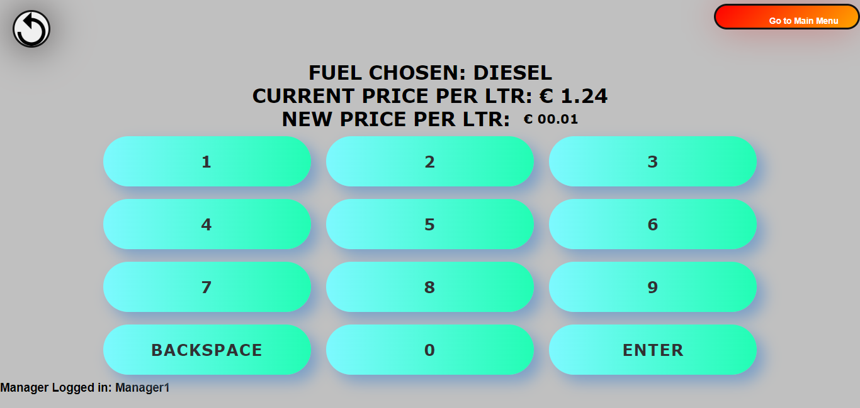

Figure 3: Pressing digit 1 from the keypad

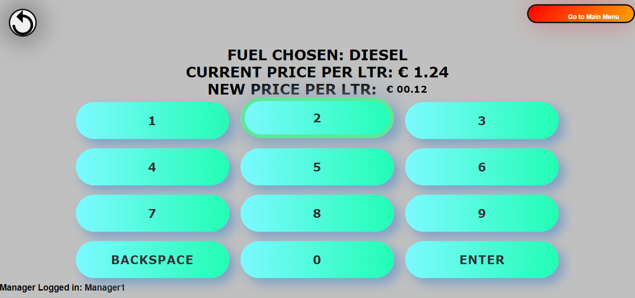

Figure 4: Pressing digit 2 from the keypad

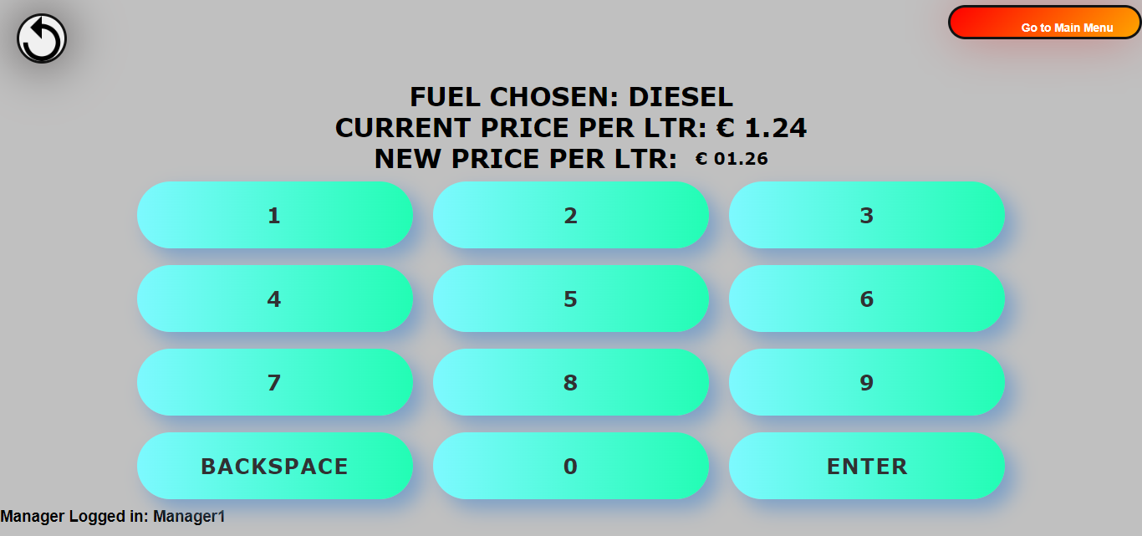Figure 5: Pressing digit 6 from the keypad and hit enter.

This is the easiest way for the user to input a price because it is the way people in Malta write (from left to right). This leads to more accurate and realistic input.

Selecting a set payment when a customer is getting fuel

For a set payment, both when paying by card or paying by cash, the customer is presented with four buttons where he can select the amount of fuel from. These can be seen in Figure 8. These four buttons represent the €5, €10, €20 and €50 notes because these are the most commonly used notes when giving fuel to your vehicle. Since the money amounts to opt for are predefined amounts, there is less room for error from the user side, which results to a more precise amount.

Moreover, the continue button only appears when the user has selected at least one of the money notes. This is so to prevent the error of a user trying to buy a €0 worth of fuel. This can be shown in the Figures 6 and 7.

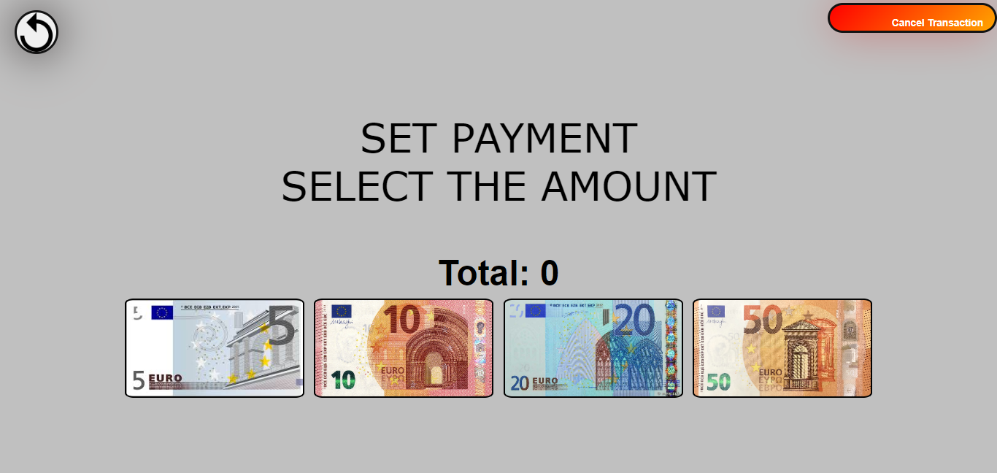Figure 6

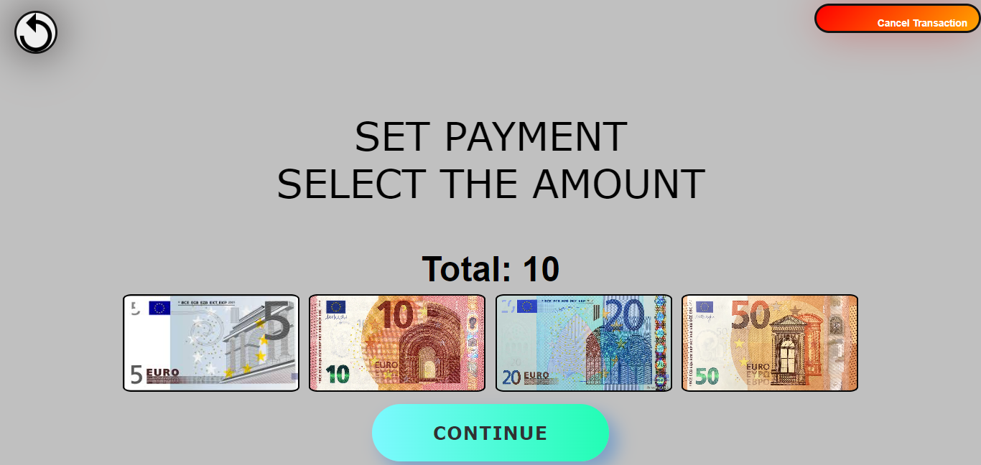

Figure 7

2. Help the system users identify and recover from Errors

While the system’s priority is always the prevention of errors, errors can still occur. When this is the case, direct feedback is given to the user in order to act upon. In many cases feedback is given under where the input value is displayed, in order to get the user’s attention.

Inputting no or an incorrect passcode in manager’s console

When the manager or an unauthorized user tries to input an empty passcode, feedback is given stating “PLEASE ENTER A PASSCODE.” as evident in Figure 8.

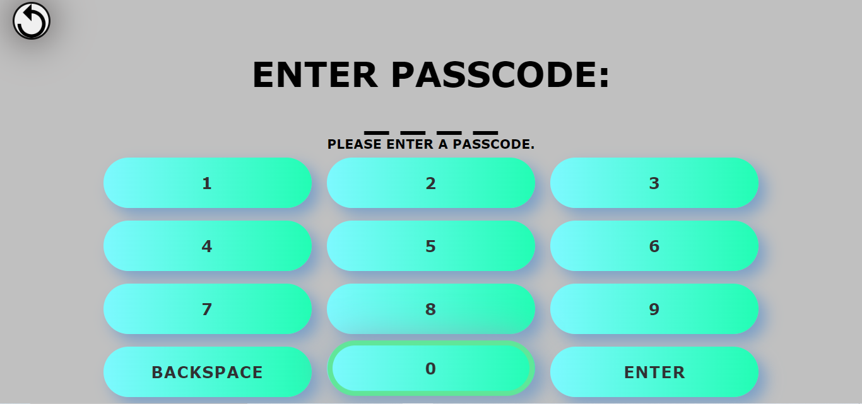

Figure 8

When the manger or an unauthorized user inputs an incorrect passcode, “INCORRECT PASSCODE” feedback is given. The feedback is once again given under where the input value is displayed, in order to get the user’s attention. This can be seen in Figure 9.

Since a passcode is a confidential type of input, when an incorrect passcode is inputted, the input field is directly reset.

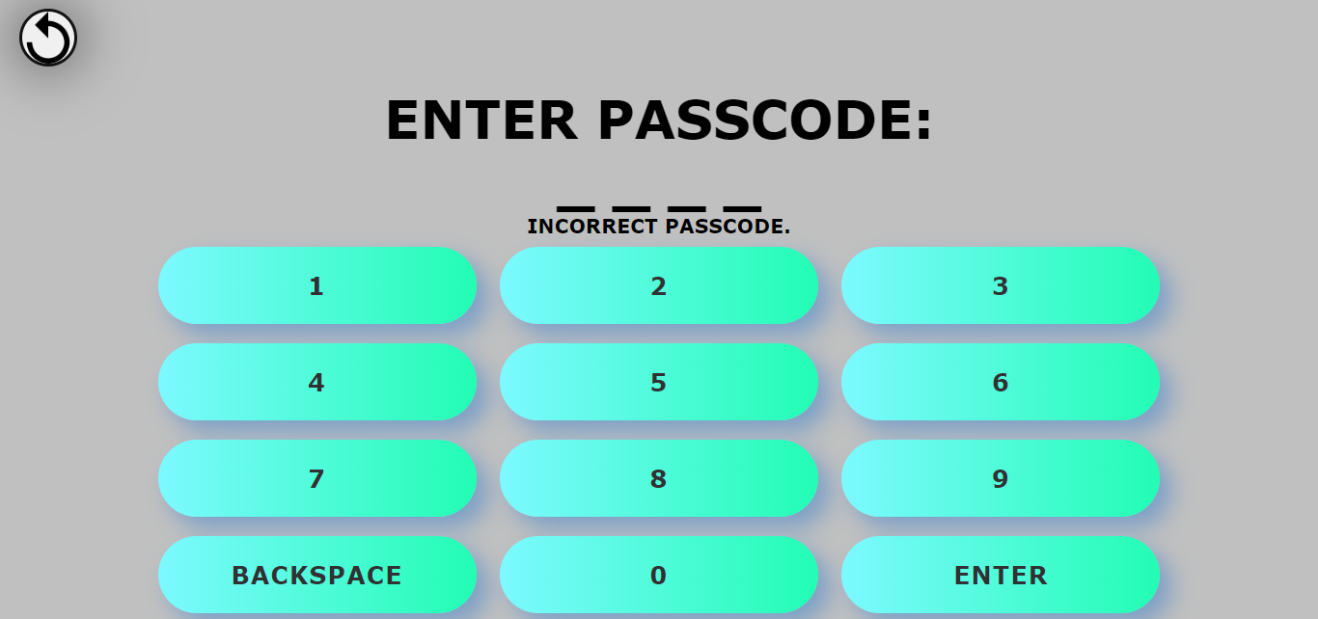

Figure 9

Entering an empty value when the manager is changing a fuel price

As the manager is using the keypad to change a fuel price and the manager tries to enter an empty value, feedback is also given to notify the manager that a value must be provided. This is evident in Figure 10.

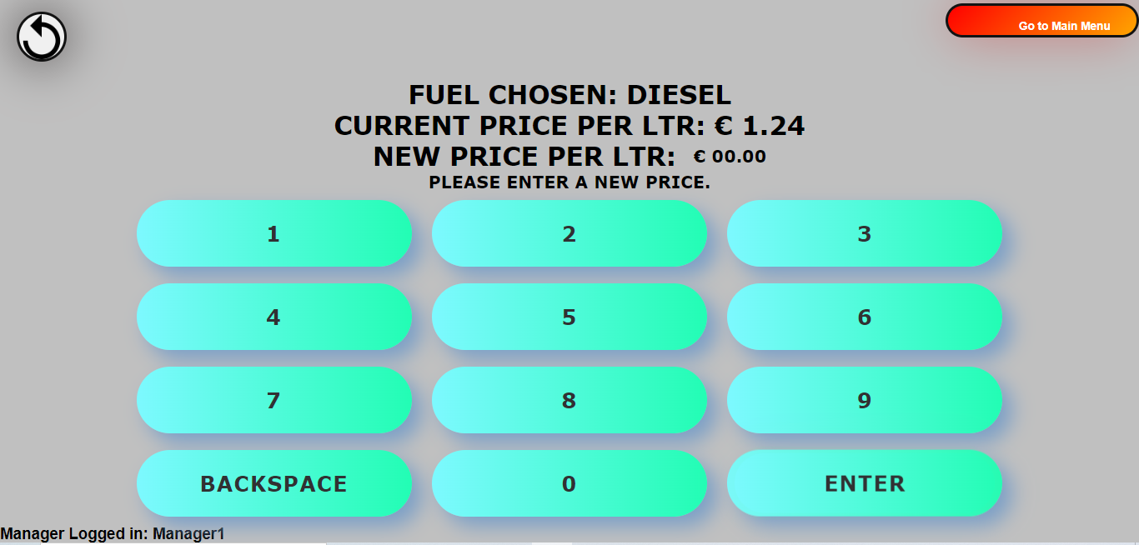

Figure 10

Card swipe denied when a customer is buying fuel by card

At this point the bank card has been already swiped as can be seen in the animation in the program. However, if the customer’s bank card is denied, the message found in Figure 11 below is displayed. Moreover, it provides the functionality for the customer to try and swipe the bank card again, in order to be able to proceed with the transaction.

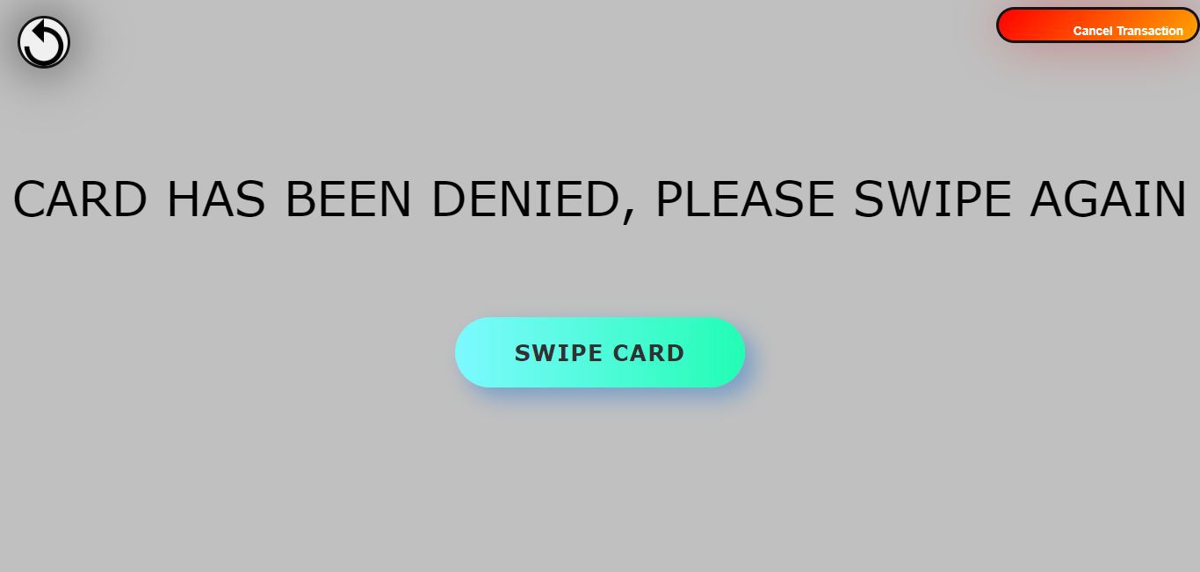

Figure 11

3. The system’s minimalistic but still having a great aesthetic design

The human brain can only process a certain amount of data and information at a particular time. Thus, unnecessary information and complications were kept to a minimum on our design screens. This type of design also helped to cater for various people with different abilities, by decreasing the chance of alarming them with a lot of information at one go.

Furthermore, the colour scheme was selected in a way to be clearly visible both during daylight and lowlight conditions at night. However, we emphasized more on the display at lowlight conditions at night since the pumping station system will be mostly used during night time by the customer. This is since during the daytime, customers are given fuel by employees of the pump company themselves. By this, text was depicted using contrasting colours such as black text on bright green coloured buttons, and black text on light grey background. Moreover, almost every text is written in capital letter format to further obtain the user’s attention. All these can be seen in the Figure 12 below.

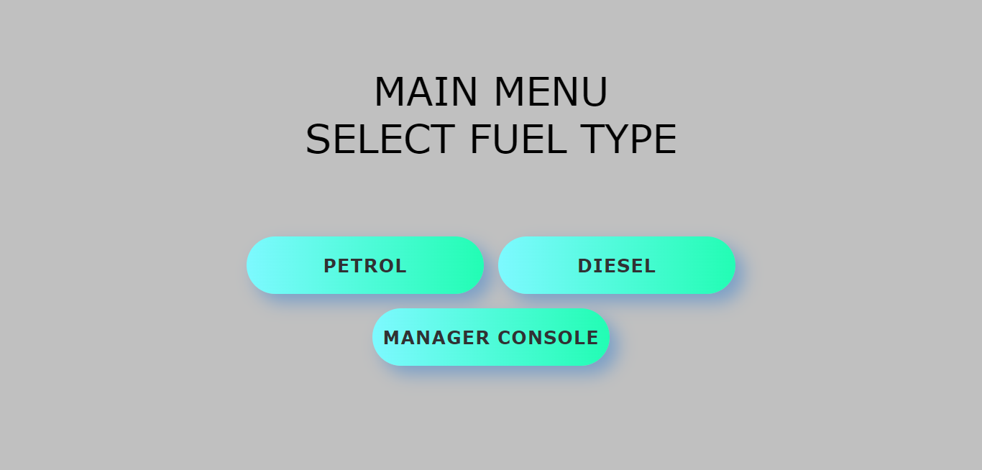

Figure 12

4. Minimal memory load on the user

It is tedious and unpractical for the user to remember every choice he made throughout the sequence of pages while using the system. Therefore in every page there are reminders to remind the user of what he has chosen so far. This is especially helpful when reaching deep inside the system, for example the payment part when the user is buying fuel.

When customer has selected to buy petrol

As a customer is buying fuel and chose petrol, the system leads him to choose the petrol quality. After choosing petrol, on the next page “SELECT PETROL QUALITY” is displayed to remind the user that in the previous page he chose petrol. This is evident in Figure 13. This also happens in the manager’s console when the manager is changing the price of any petrol type.

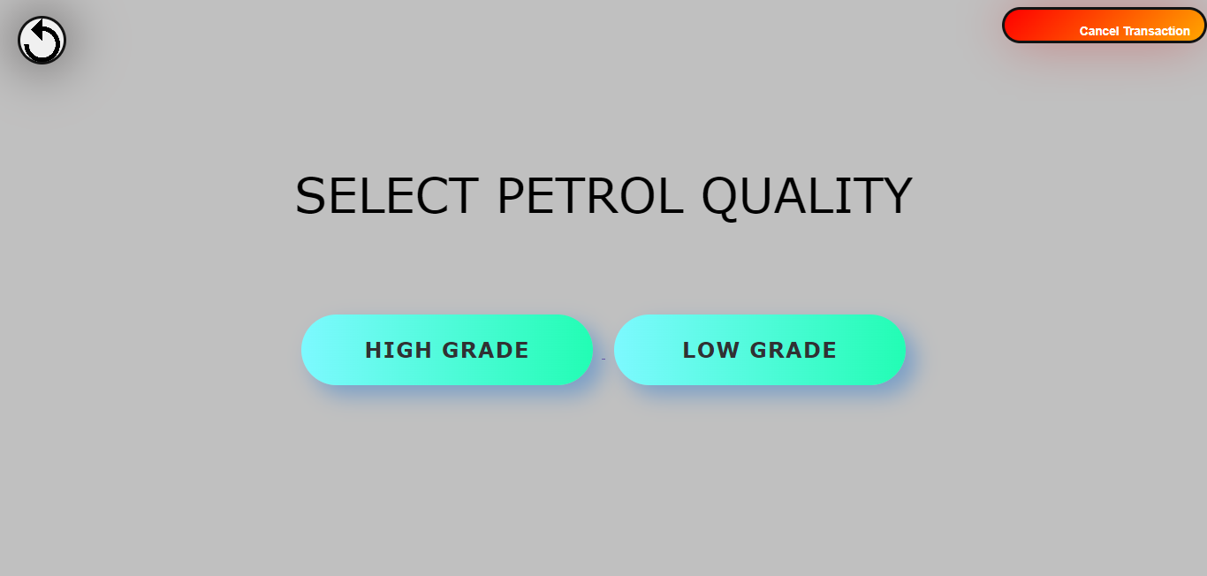

Figure 13

When the manager is changing a fuel price

When the manager is setting a new fuel price, a page is presented after choosing the type of fuel for which to set a new price. This page is portrayed in Figure 14. In this page, the fuel chosen and current price per litre are already there as a reminder to the manager of what he chose in previous pages. The manager’s username can also be seen at the bottom of the manager’s page to notify who is the manager currently using and eventually editing in the computerized system.

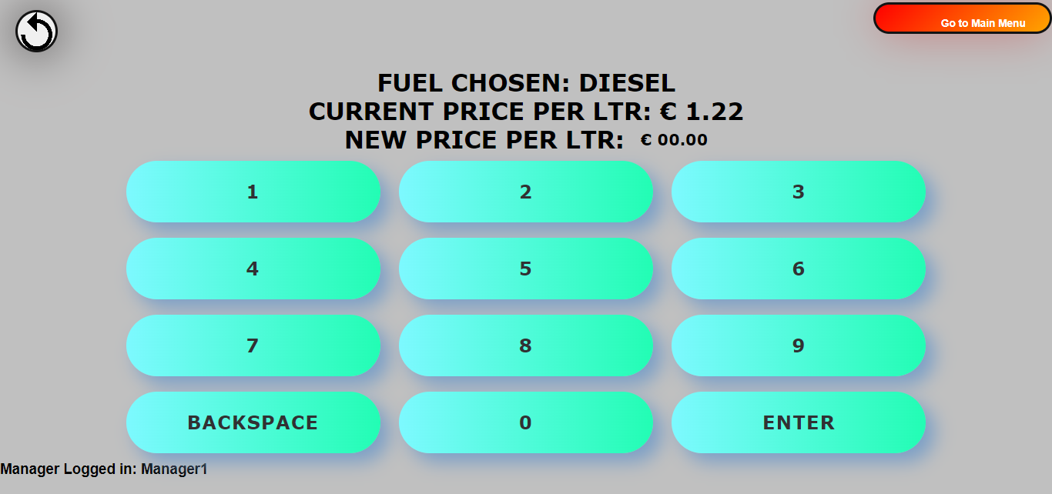

Figure 14